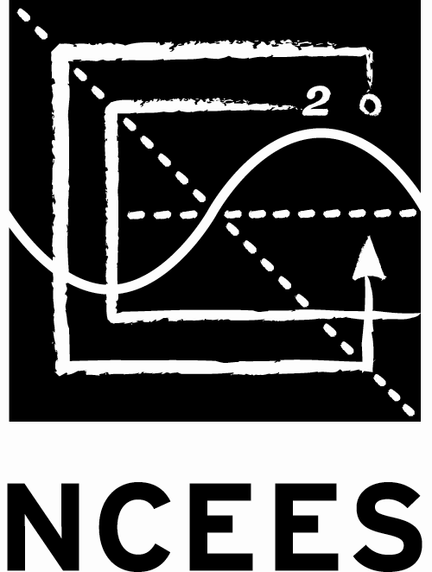

Photo
(5 cm x 5 cm)
National Council of Examiners
for Engineering and Surveying

Japan PE/FE Examiners Council
FE EXAMINATION
Please type or print clearly in dark ink. Application must be completed in English.
and in Japanese for the Supplemental Information in the 2nd page.

APPLICATION FOR ADMITTANCE

This application is to determine your eligibility to take this examination as a candidate of the computer-based FE examination administered by National Council of Examiners for Engineering and Surveying (NCEES)/Japan PE/FE Examiners Council (JPEC). The applicant shall complete this application and supplemental information (2 pages ONLY) and submit them to JPEC if you are a candidate for this examination.
First Name |  |  |  | MI | Last Name |  |  | Nationality |  | Date of Birth |  |  |  | Age |  | Gender
 |  |  |  |  |  |  |  |  |  | month/day/year |  |  |  |  |  | □Female  □ Male
Mailing Address |  |  |  |  |  |  |  | City |  |  |  |  | Country
Postal Code |  | Tel |  |  |  | E-mail Address |  |  |  |  | BPN or SSN ^{*1}
 |  | Home:
 |  | Cell Phone:
Engineering Education ^{*2} (Please list all graduate and undergraduate studies including master and doctor courses.)
College or University  Faculty / Department |  |  |  |  |  |  | Dates of Attendance  (Month/Day/Year) |  | Date or Expected Date  of Graduation  (Month/Day/Year) |  |  |  |  |  | Degree Received  or Expected  (i.e., B. Eng)

from

to

from

to

from

to
Employment |  |  |  |  |  |  | Department |  |  |  |  | Section

Company Address/Telephone/Email Address
 |  |  |  |  |  |  |  |  |  |  |  | Tel:
 |  |  |  |  |  |  |  |  |  |  |  | Email:
Exam Site |  |  | Number of Seating for FE Exams
□Pearson VUE, Tokyo  □ Pearson VUE, Osaka |  |  | □First  □Once or more / The exam site and year at the immediate past exam: □Japan □Others Year of
Exam Selection | □Chemical □Civil □Electrical and Computer □Environmental □Industrial and Systems □Mechanical □Other Disciplines
^{*1} Japan “Basic Pension Number” (BPN) – 10 digits or U.S. Social Security Number (SSN) – 9 digits.
^{*2} The certificate of graduation and transcripts, both in English (original) shall be submitted together with this application. This requirement is waived for the applicants who submitted them at the 1st FE exam application.
^{*3} The above private information shall be used for the JPEC’s activities only in terms of the FE and PE exams.

Affirmation—By my signature below, I affirm that I have attained senior status or am a graduate of a four-year engineering program offered by a Japanese or United States college or university. I am the applicant named in this application, I have read the contents thereof, and, to the best of my knowledge and belief, the foregoing statements are true and correct in every respect.

Print Name Signature of Applicant Date (Month/Day/Year)

提出用書類（Document for Submission）
日本 PE・FE 試験協議会

FE試験受験申込書（副票）
(Supplemental Information to FE EXAM APPLICATION)
Please fill out this form in Japanese as much as possible and submit it. This is especially important for us to ensure the right delivery address for return mail.
本票に日本語にて正確に記入し提出願います。
FE試験受験科目：
記入日： 年 月 日
ふりがな | ふりがな
氏 | 名

住 所 （建物名等も記入願います。）
〒 －

都 道

府 県
学 歴 |  | 在学期間  (年月) | 卒業年月  (含む予定) |  | 学位
大学 / 学部 / 学科： |  | 自  至
大学院 / 研究科 / 専攻： |  | 自  至
高専 / 学科 / 専攻科： |  | 自  至
勤務先 |  | 部 |  | 課

勤務先住所
〒 －

都 道

府 県
PE・FE資格（試験）の事をどこで知ったのか下記より選択してください（きっかけ等当てはまるもの全て）。
□JPECホームページ □会社 □友人 □学校 □学校講師等 □校内セミナー □試験のポスター □ブログ,SNS等
□企業セミナー □JPEC開催セミナー（ ） □その他（具体的に） （ ）
注、 個人情報の取り扱いについて：
上記の個人情報は、JPECが試験・啓蒙事業のためにのみ使用されるもので、他の目的で使用されるものではありません。

!提出の前に! 願書(APPLICATION)を再確認ください。特に誕生日、BPNの記載ミスや抜け、自筆サインを
サインとして認められる（少なくとも筆記体で）しているか？(ブロック体は×サインと認められません。)

提出用書類（Document for Submission）

National Council of Examiners for Engineering and Surveying

Japan PE/FE Examiners Council

FE EXAMINATION

APPLICATION INSTRUCTIONS
FUNDAMENTALS OF ENGINEERING EXAMINATION

The following instructions have been prepared to assist you in completing your application for the computer-based Fundamentals of Engineering (FE) examination. Proper attention to details will help avoid delays in processing and will expedite final review of your application. Failure to fill out the application form completely and properly will not only cause delays but may result in the inability to qualify you for the FE exam.

WHO IS ELIGIBLE TO APPLY
Applicants must be:
- Those who are graduates of a four-year program leading to a Bachelor of Science degree in engineering or, who have been awarded a graduate (Masters or Ph.D.) degree in Engineering; or
- A student who is currently enrolled in a four-year engineering program offered by a Japanese college or university and who has attained senior status. Senior status is defined as having attained sufficient academic credits that the applicant expects to be awarded a Bachelor of Engineering or science degree in engineering within 12 months of the administration of the FE exam; or
- The graduates of National Institute (College) of Technology who obtained Bachelor of Engineering Degree through the additional 2 years advanced course education or transferred to the third year of university or college after graduation of the 5 years department education; and
- A resident in Japan. Japanese nationality is not required.

PROCESSING OF APPLICATIONS
With JPEC:
Through an agreement between National Council of Examiners for Engineering and Surveying (NCEES) and the Japanese PE/FE Examiners Council (JPEC), eligible candidates will complete and file their applications with JPEC, and provide their certificate of graduation and transcript, both in English (original) and pay an application fee to JPEC. JPEC will provide assistance to candidates as needed to complete the applications. Candidates who are deemed to be eligible by JPEC for seating for the FE examination will be directed to access the NCEES Web site.
With NCEES:
The candidates will access MyNCEES in the NCEES Web site to create an NCEES account and complete an NCEES Web-based registration form for the specified exam. The candidates will pay the required exam fee to NCEES during the NCEES Web-based registration using a VISA or MasterCard credit card and once confirmed by JPEC. The candidates will then be allowed to select an appointment time to take the exam at an approved Pearson VUE test center. Candidates not qualified for seating to the exam will be notified in writing and be advised of any noted deficiencies.

Application forms and required application fees will be forwarded to:

Japan PE/FE Examiners Council
Room#201, Ishii No. 3 Building, 2-15-9
Akasaka, Minato-ku, Tokyo, 107-0052, Japan
Tel: 81-3-3583-8781
Fax: 81-3-6277-7860
E-mail: info@jpec2002.org

提出不要（Document for non-submission）

FEES
Application Fee:
Candidates will be required to submit to JPEC an application fee equal to JPY22,000 (JPY17,000 for students) associated with the evaluation of applications and qualification of candidates. The receipt copy shall be attached on the reverse of the supplemental information of the application.
Exam Fee:
During the NCEES Web-based registration process, candidates will be required to submit to NCEES an amount equal to US$200 (including Pearson VUE fee) using a VISA or MasterCard credit card. This fee will be inclusive of all expenses associated with the administration and scoring of the FE exam.

APPLICATION PERIODS
The Fundamentals of Engineering (FE) examination will be the computer-based examination which will be offered during four testing windows throughout the year: January–March, April–June, July–September, and October–December. Registration will be open year-round.

EXAM RESULTS
Once the candidate has taken the exam, their results will be posted in their NCEES account within 7 to 10 days. The exam results will also be made available to JPEC and will also be retained by NCEES and available for confirmation upon written request by the candidate, JPEC, or a Member Board of NCEES. All exam results will be reported as pass or fail and no numerical scores will be provided. Once the results of the examination have been posted, candidates should contact JPEC for additional information or instructions.

NCEES EXAMINEE GUIDE
The NCEES Examinee Guide which is the official guide to policies and procedures for the NCEES exams will give candidates further information or instructions such as re-scheduling, cancellations or refunds. All examinees are required to read this document before starting the exam registration process. It is your responsibility to make sure that you have the current version.

提出不要（Document for non-submission）

