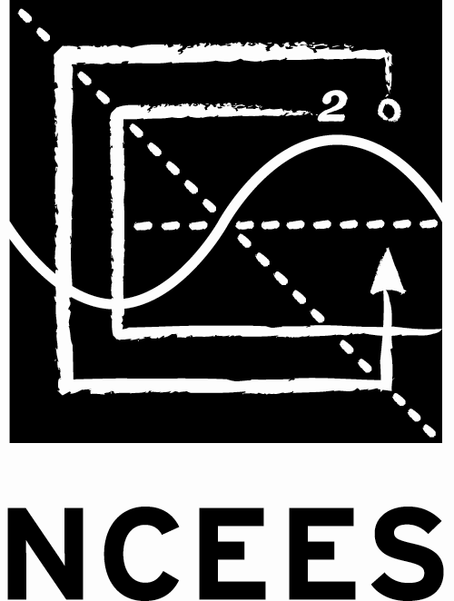
National Council of Examiners
for Engineering and Surveying

Japan PE/FE Examiners Council

PE-EXAMINATION

Check each box below if you read the contents and send with your application sheet.
Certification

By signing the application sheet next page, I hereby certify that all statements and certifications in this application are true and correct. I have not withheld information that might affect the decisions to be made concerning this application. I am aware that a false, inaccurate, or dishonest statement may be punishable by law or be grounds for denial of this application, my license application, and for disciplinary action against future licenses. I hereby authorize JPEC and NCEES to investigate any statements made by me in this application.

Note of the Application sheet

^{*1} Japan “Basic Pension Number” (BPN) – 10 digits or U.S. Social Security Number (SSN) – 9 digits.
^{*2} The certificate of graduation and transcripts, both in English (original) shall be submitted together with this application. This requirement is waived for the applicants who submitted them at the FE exam application.
^{*3} The above private information shall be used for the JPEC’s activities only in terms of the FE and PE exams.
Please type or print clearly in dark ink. Application must be completed in English. And in Japanese for the Supplemental Information in the 3rd page.

Application for Admittance

This application is to determine your eligibility to take this examination as a candidate of the PE examination administered by National Council of Examiners for Engineering and Surveying (NCEES)/Japan PE/FE Examiners Council (JPEC). The candidate shall complete this application and supplemental information (3 pages ONLY) if you are a candidate for this examination and you have taken and passed the Fundamentals of Engineering (FE) examination.

提出用書類（Document for Submission）
PE-Examination Application Sheet

Photo
(5 cm x 5 cm)
Exam Discipline Declaration (Please check which discipline of the Principles and Practice of Engineering exam you wish to take.) | Exam Site
All Computer-Based Exams:  SD = Single-day, date to be determined  □Agricultural and Biological (SD) □Architectural Engineering (SD) □Control Systems (SD)  □Electrical and Computer (Computer Engineering) (SD)  □Electrical and Computer (Electronics, Controls, and Communications) (SD)  □Fire Protection (SD) □ Industrial and Systems (SD) □Metallurgical and Materials (SD) □Mining & Mineral Processing (SD) □Naval Architecture and Marine (SD)  □ Nuclear (SD) □Petroleum (SD)  YR = Year-round  □Chemical (YR) □ Civil (YR) □ Electrical/Computer (Power) (YR) □Environmental (YR) □ Mechanical (YR) | □Pearson VUE Tokyo  □Pearson VUE Osaka
Progressive Engineering Experience | Eng. Experience
Candidates shall complete the Record of Progressive Engineering Experience (see attached form) with sign and date and submit to JPEC together with this application. | Years

First Name |  | MI | Last Name |  | Nationality |  | Date of Birth |  | Age | Gender
 |  |  |  |  |  |  | month/day/year |  |  | □Female  □ Male
Mailing Address |  |  |  |  | City |  |  |  | Country
Postal Code | Tel |  |  | E-mail Address |  |  |  | BPN or SSN ^{*1}
 | Home:
 | Cell Phone:
Engineering Education ^{*2}
(Please list all graduate and undergraduate studies including master and doctor courses.)
College or University  Faculty / Department |  |  |  |  | City | Country |  | Degree |  | Date
Employment |  |  |  |  | Department |  |  | Section

Company Address/Telephone/Email Address
 |  |  |  |  |  |  |  | Tel:
 |  |  |  |  |  |  |  | Email:

You have passed the FE Exam by;

□NCEES/JPEC: When? Month Year

□State Board: When? Month Year Which state?

Did you take the PE exam before?

□First Time □Second Time; When? Month Year Which State Board?

□ Third or More Time Month Year Which State Board?

Month Year Which State Board?
^{*1} Japan “Basic Pension Number” (BPN) – 10 digits or U.S. Social Security Number (SSN) – 9 digits.

Print Name Signature of Applicant Date

提出用書類（Document for Submission）
日本 PE・FE 試験協議会
PE試験受験申込書（副票）
(Supplemental Information to PE EXAM APPLICATION)
Please fill out this form in Japanese as much as possible and submit it.
This is especially important to ensure the delivery of mail.
本票に日本語にて正確に記入し提出願います。

PE試験受験科目：
記入日： 年 月 日
ふりがな | ふりがな
氏 | 名

住 所 （郵便物を確実に届けるため建物名等の記入願います。）
〒 －

都 道

府 県
学 歴 |  | 在学期間  (年月) | 卒業年月  (含む予定) |  | 学位
大学 / 学部 / 学科： |  | 自  至
大学院 / 研究科 / 専攻： |  | 自  至
高専 / 学科 / 専攻科： |  | 自  至
勤務先 |  | 部 |  | 課

勤務先住所
〒 －

都 道

府 県
PE・FE資格（試験）の事をどこで知ったのか下記より選択してください（きっかけ等当てはまるもの全て）。
□JPECホームページ □会社 □友人 □学校 □学校講師等 □校内セミナー □試験のポスター □ブログ,SNS等 □企業セミナー □JPEC開催セミナー（ ） □その他（具体的に） （ ）

注、個人情報の取り扱いについて：
上記の個人情報は、JPECが試験・啓蒙事業のためにのみ使用されるもので、他の目的で使用されるものではありません。

!提出の前に! 願書(APPLICATION)を再確認ください。特に誕生日、BPNの記載ミスや抜け、自筆サインを
サインとして認められる（少なくとも筆記体で）しているか？(ブロック体は×サインと認められません。)

提出用書類（Document for Submission）

National Council of Examiners for Engineering and Surveying
Japan PE/FE Examiners Council
PE EXAMINATION
APPLICATION INSTRUCTIONS
PRINCIPLES AND PRACTICE OF ENGINEERING EXAMINATION

The following instructions have been prepared to assist you in completing your application for the Principles and Practice of Engineering (PE) examination. Proper attention to details will help avoid delays in processing and will expedite final review of your application. Failure to fill out the application form completely and properly will not only cause delays but may result in the inability to qualify you for the PE exam.

WHO IS ELIGIBLE TO APPLY
Applicants must be:
- Those who have been awarded a Bachelor of Science, Masters, or Ph.D., degree in engineering.
- Individuals who have taken and passed the Fundamentals of Engineering (FE) Examination; and
- A resident in Japan. Japanese nationality is not required.

PROCESSING OF APPLICATIONS
With JPEC:
Through an agreement between the National Council of Examiners for Engineering and Surveying (NCEES) and the Japan PE/FE Examiners Council (JPEC), eligible candidates will complete and file their applications with JPEC and pay an application fee to JPEC. JPEC will provide assistance to candidates as needed to complete the applications. Candidates, who are deemed to be eligible by JPEC for seating for the PE examination, will be directed to access the NCEES Web site.
With NCEES:
The candidates will access MyNCEES in the NCEES Web site to create an NCEES account and complete an NCEES Web-based registration form for the specified exam. The candidates will pay the required exam fee to NCEES during the NCEES Web-based registration using a VISA or MasterCard credit card and once confirmed by JPEC.

The candidates, who have been qualified for the computer-based PE examination, will then be allowed to select an appointment time to take the exam at an approved Pearson VUE test center.
Candidates not qualified to take the exam will be notified in writing and be advised of any noted deficiencies.

Application forms and required application fees will be forwarded to:

Japan PE/FE Examiners Council
Room#201, Ishii No. 3 Building, 2-15-9
Akasaka, Minato-ku, Tokyo, 107-0052, Japan
Tel: 81-3-3583-8781
Fax: 81-3-6277-7860
E-mail: info@jpec2002.org

提出不要（Document for non-submission）

FEES
Application Fee:
Candidates will be required to submit to JPEC an application fee equal to JPY35,000 associated with the evaluation of applications and qualification of candidates. The receipt copy shall be attached on the reverse of the supplemental information of the application.
Exam Fee:
During the NCEES Web-based registration process, candidates will be required to submit to NCEES an amount equal to US$400 (including Pearson VUE fee) for CBT using a VISA or MasterCard credit card. This fee will be inclusive of all expenses associated with the administration and scoring of the PE exam.

APPLICATION PERIODS
The Computer-Based Principles and Practice (PE) examination will be offered during four testing windows throughout the year: January–February, April–May, July–August, and October–November. Registration will be open year-round.

EXAM RESULTS
For the Computer-Based PE examination, their results will be posted in their NCEES account within 7 to 10 days.
The exam results will also be made available to JPEC and will also be retained by NCEES and available for confirmation upon written request by the candidate, JPEC, or a Member Board of NCEES.
All exam results will be reported as “pass” or “fail” and no numerical scores will be provided. Once the results of the examination have been posted, examinees should contact JPEC for additional information or instructions. No printed NCEES or JPEC certificate will be available.

NCEES EXAMINEE GUIDE
The NCEES Examinee Guide which is the official guide to policies and procedures for the NCEES exams will give candidates further information or instructions such as re-scheduling, cancellations or refunds. All examinees are required to read this document before starting the exam registration process. It is your responsibility to make sure that you have the current version.

REGISTRATION as Professional Engineer
It is the responsibility of the examinee, who passed the PE Exam offered by NCEES/JPEC, that he or she will register his or her P.E. license to a U.S. Licensing Board. Each U.S. Licensing Board has their requirements for P.E. licensure e.g. education as per EAC of ABET or NCEES credential evaluation, 4 years progressive engineering experience, etc. Passing the PE Exam does not guarantee that your application for licensure as a Professional Engineer will be approved. You must confirm and meet the Licensing Board requirements prior to applying for licensure.

提出不要（Document for non-submission）

